

University of Asia Pacific
Department of CSE
Assignment On
Comparison of Round Robin, SJF, and FCFS CPU Scheduling Algorithms
Course Title: Operating System Lab
Course Code: CSE 402
Submitted To  Atia Rahman Orthi  Lecturer  Department of Computer Science  and Engineering  University of Asia Pacific | Submitted By  Tashnimul Hasan Shifat  ID: 23101142  2022–2023 Batch  Department of CSE  University of Asia Pacific

Date of Submission: 17 August 2026

- Problem:
Implement the following CPU Scheduling Algorithms for the given set of processes:
Process | Arrival Time (AT) | Burst Time (BT)
P1 | 0 | 7
P2 | 1 | 4
P3 | 2 | 15
P4 | 3 | 11
P5 | 4 | 20
P6 | 4 | 9
Implement the following scheduling algorithms:
- Round Robin (RR) with Time Quantum = 5
- Shortest Job First (SJF) – Non-Preemptive
- First Come First Serve (FCFS)
For each scheduling algorithm, calculate:
- Completion Time (CT)
- Turnaround Time (TAT)
- Waiting Time (WT)
- Average Turnaround Time (AVG TAT)
- Average Waiting Time (AVG WT)
Also, represent the process execution sequence/Gantt Chart for each algorithm.
Finally, compare the Average TAT and Average WT of Round Robin, SJF, and FCFS and determine which scheduling algorithm performs better for the given set of processes. Explain the reason for the difference in performance.

- Source Code:

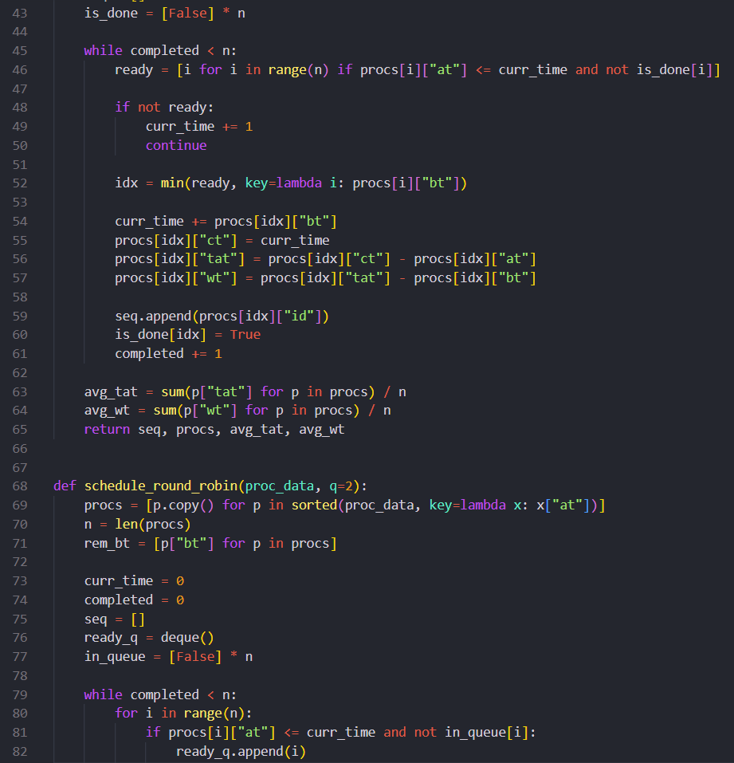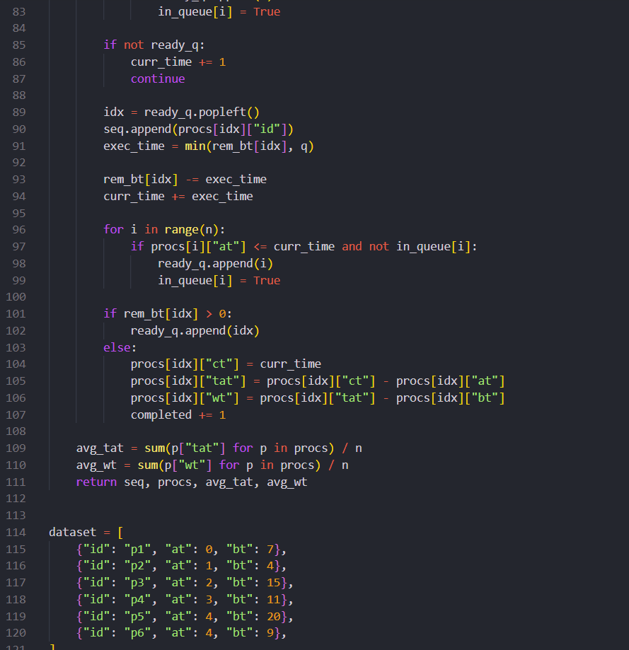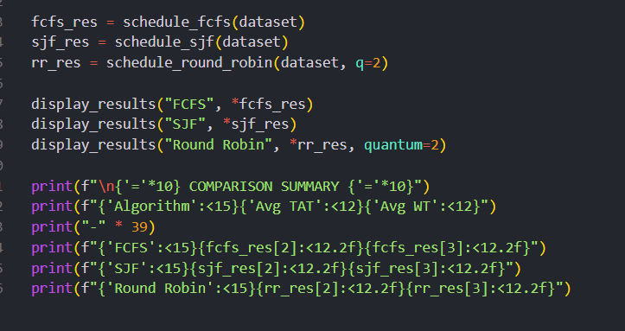

- Output:

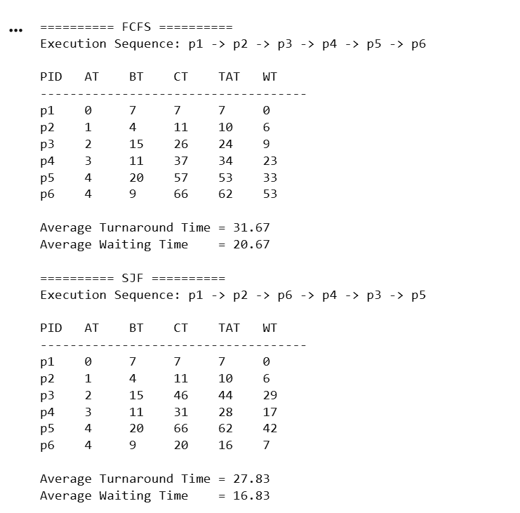
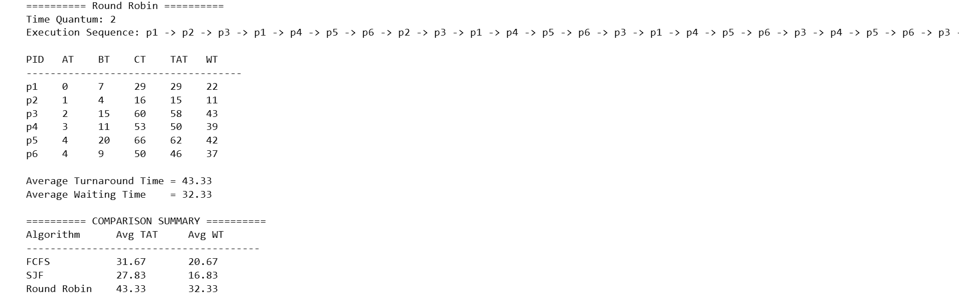

- Discussion:
This experiment evaluated three CPU scheduling techniques: Round Robin (RR), Shortest Job First (SJF), and First Come First Serve (FCFS), using an identical set of six processes. Their performances were analyzed by comparing Completion Time (CT), Turnaround Time (TAT), and Waiting Time (WT).
Among the three methods, SJF produced the most efficient results for the given workload. It achieved an Average TAT of 27.83 units and an Average WT of 16.83 units, both of which were the lowest. FCFS showed comparatively moderate results, with an Average TAT of 31.67 units and an Average WT of 20.67 units. On the other hand, Round Robin, using a time quantum of 5 units, resulted in an Average TAT of 42.17 units and an Average WT of 31.17 units.
The lower waiting and turnaround times of SJF indicate that selecting shorter processes first can improve CPU scheduling efficiency for this particular process set. FCFS is simpler because processes are handled according to their arrival order, but longer processes can cause other processes to wait. RR ensures that each process receives regular CPU time, making it suitable for interactive and time-sharing environments; however, the repeated context switching and time-slice allocation led to higher waiting and turnaround times in this experiment.

- Conclusion:

The experiment demonstrated the performance differences between RR, SJF, and FCFS scheduling algorithms. Based on the calculated CT, TAT, and WT values, SJF provided the best performance for the selected processes, achieving the lowest Average TAT (27.83) and Average WT (16.83).
FCFS ranked second, with an Average TAT of 31.67 and an Average WT of 20.67, while RR produced the highest values, with an Average TAT of 42.17 and an Average WT of 31.17.
Although RR has the advantage of providing fair CPU time to every process, it was not the most efficient method for this particular workload. Therefore, when the primary objective is to reduce waiting and turnaround time for these processes, SJF is the most suitable scheduling algorithm among the three tested methods.

6.Github_Link
https://github.com/shifat35/Operation_System_Lab-CSE-402-.git

